Orientation Discrimination using SDT
PSY310 Lab in Psychology
30th September 2026
Vridhi G Jain
AU2420124

Introduction:
Signal detection theory is a theoretical framework for understanding how a subject makes decisions under uncertainty. It is mainly applicable when the judgements need to be based on noisy, ambiguous evidence like concluding whether a faint stimulus was present. The SDT helps separate discriminability and response bias, helping quantify their performance. Accuracy depends on how well subjects make the distinction between signal and noise (Wixted, 2026).
SDT has four outcomes:
- Correct Detection: the signal is present, and the subject correctly identifies it.
- Miss : the signal is present, but the subject fails to detect it.
- False Alarm: the signal is absent, but the subject believes it is present.
- Correct Rejection: the signal is absent, and the subject identifies it to be absent.

Method:

Participant
The participant was a 21-year old female undergraduate student at Ahmedabad University. Participation was voluntary, consent was taken prior to the study and confidentiality was established.

Materials and Procedure
The study was conducted using PsychoPy v2026.2.3 on a laptop with a dimension of 14 inches with a resolution 1920x1200 pixels and a refresh rate of 60 Hz. There were a total of 100 trials conducted. On each trial, a fixation was presented for 100 milliseconds and followed by that, a sinusoidal shape with a Gaussian mask appeared for 300 milliseconds. The grating was either vertical (tilt of 0 degrees) or tilted between 5 to -5 to left (negative value) or right (positive value).

The vertical trials were treated as the noise condition, and the trials with the tilt were treated as the signal condition. The order of the trials were randomized and the participant responded to the stimulus using either the down arrow key for the signal trials and up arrow key for the noise trials on the laptop keyboard.

The reaction time and accuracy of the participants' responses were recorded and saved to an Excel file.

Figure 1 – Stimuli, Sinusoidal shape with a Gaussian mask


Figure 2 – Fixation (triangle)

Results:

Hit rate = 30/55 = 0.545
False alarm rate = 10/45 = 0.222
d’ = 0.88
c = 0.33
The participant made 30 hits, 25 misses, 10 false alarms and 35 correct rejections. These values gave a hit rate of 0.55 and a false alarm rate of 0.22. The overall accuracy was 65% and the mean reaction time was 0.70 seconds.
The participants sensitivity (d’) was 0.88 and the criterion ( c ) was 0.33.

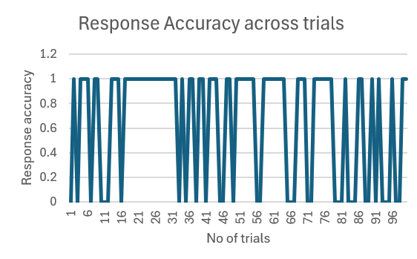
Figure 3 – response accuracy across trials

The figure above depicts the participant’s response accuracy (1 is correct, 0 is incorrect) across the 100 conducted trials. As inferred, the accuracy does not stay static – rather, it fluctuates. There are a considerable volume of errors in the former trials (trial 1-16) which were followed by the longest stretch of correct responses (trial 17-32). However, after this segment, errors were frequent with the least accuracy appearing in the last 25 trials.

Discussion:
The d’ of 0.88 shows that the participant could discriminate between the tilted gratings from upright ones. However, the sensitivity was moderate. The hit rates were higher than the false alarm rates, but the participant also missed 25 of 55 trials – majority of misses came from the smaller tilts while the larger tilts were detected more accurately. Performance fell in the latter half of the experiment which could be due to fatigue or straying of attention as the trials progressed.

The criterion (0.33) is positive which indicates that the participant was conservative i.e, needed strong evidence before reporting a tilt and hence, tended to respond that no signal was present. This resulted in more misses (25) than false alarms (10) and kept her overall accuracy low – 65%. The d’ shows how well the participant could signal from noise, while the c shows how cautious she was while saying yes.

References

Wixted, J. T. (2026). Signal detection theory — OECS. Open Encyclopedia of Cognitive Science. https://oecs.mit.edu/pub/608a12kc/

